5Plus Project Status

# Thin Client: Status 100%

Thin client is the connecting application between the data collection apps that interface with the Kinect and the web server.

* Interface with the data collection applications
* Interface with the web server
* Processing the requests coming from the web server, pass them on to the data collection application and return the results back to the web server.

# Web Server: Status 80%

Web server manages the patient, physician and test information in the database as well as controlling the evaluation requests from the client. Main features include:

* Interface for the thin client – 100%
* Interface for the web and mobile applications – 100%
* Manage the database with the data for patients, physicians, evaluations etc. – 20%
* Manage physician logins – 20%
* Provide interface for getting past evaluation results – Not started

# Web/Mobile Client – 30%

* Design the interface with the web server – 100%
* Design the user interface – 30%
* Integrate with the server – Not Started

# Web User Interface

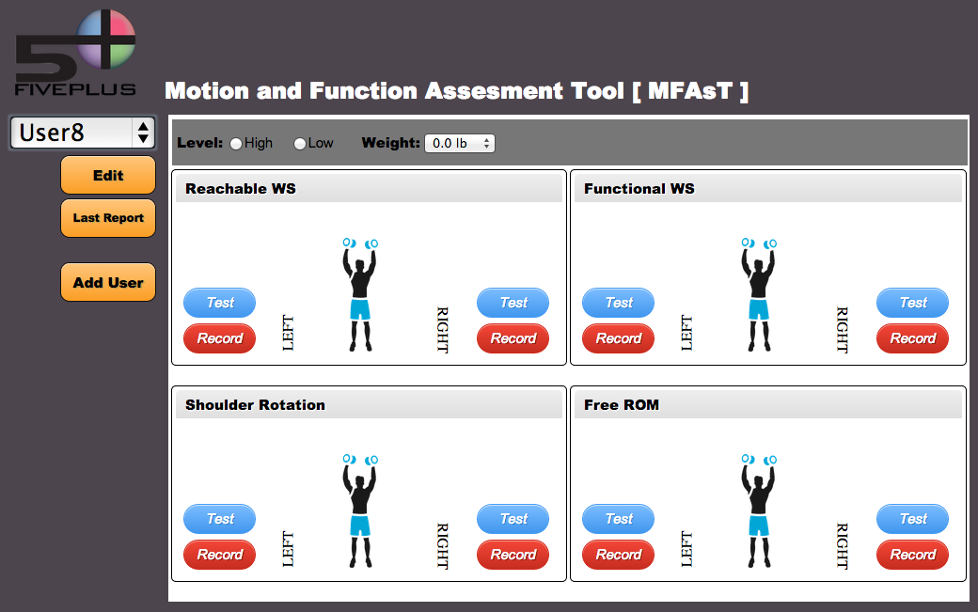

# Mobile User Interface

